# Beef Nutrition!

Fill in the blanks during your class discussion about beef nutrition. Then, keep this worksheet to reference later!

****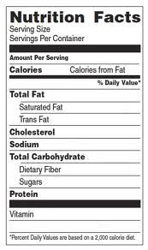

0 grams

50 grams

High amounts of protein, zinc, and iron (ZIP)

Yes!

Zinc, iron

26 grams

12 grams

217

3 ounces

**What food group is beef in?**

Protein

**Can beef be a part of a healthy diet?**

**What makes beef healthy or unhealthy?**

**What beef nutrition facts are most important to you?**

s:

Other notes to remember:

**My beef product: My group members:**